**Mental Health and Wellbeing Ambassadors**

Handbook



**Things to remember**

* You are not responsible to ‘fix’ anyone’s mental health problems
* You have to put your own mental health and wellbeing first
* Your job is to offer promote and advise in the moment, if appropriate, but ALWAYS pass on to a member of staff to ensure the wellbeing and correct support for yourself and others
* If you are ever unsure of anything then it is okay to tell someone you need to get some advice and come and speak to Miss Abram
* You should be very proud of yourself for supporting your own, and others, mental health and wellbeing



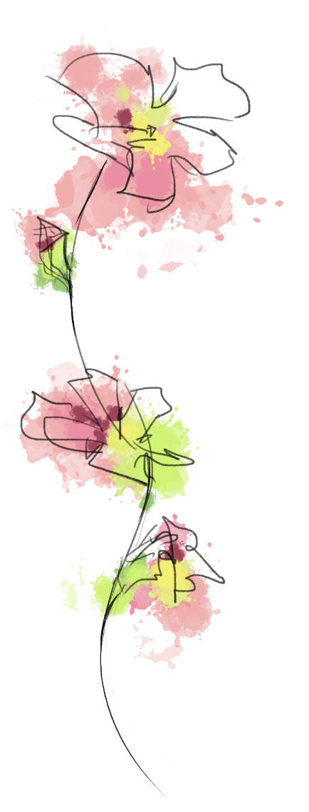

**Anxiety**

**What is it?**

* Anxiety or worry is completely normal and everyone worries at some point over something, but sometimes some people can worry too much and it can get in the way of doing things and impact our day to day life.
* Distressing anxiety and worry is when worry is difficult to control or taking up all of someone’s time and they are am not doing things they enjoy because of it
* Anxiety comes from our body’s natural reaction to danger (fight-flight-freeze response) but your brain has ‘tricked’ you in thinking you are in danger when you are actually worried about something.

**Top tips?**

* Grounding – coping strategies to help reconnect you with the present and bring you out of a panic
* Breathing skills - to lower stress in the body by sending a message to your brain to calm down and relax. The brain then sends this message to your body.

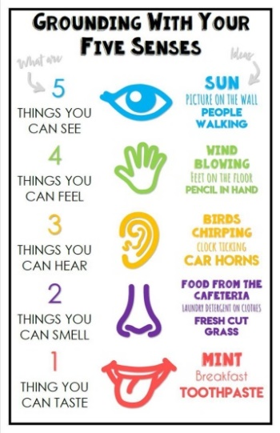**Grounding and Deep Breathing Skills**

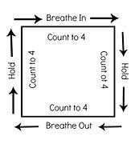



**Low mood/ Depression**

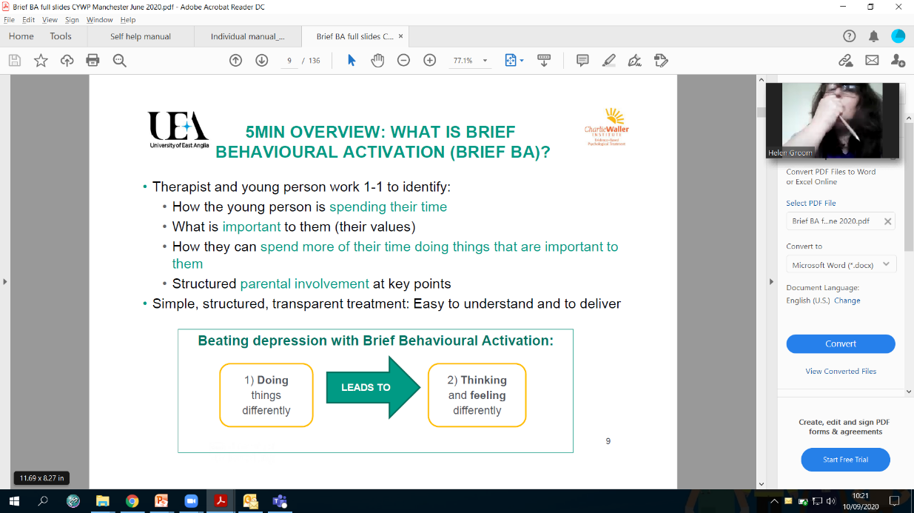

* Make us feel better about ourselves
* Make us feel less tired
* Motivate us to do more
* Help us to think more clearly
* Give us a sense of achievement

**Top tips?**

Find out what they enjoy to do and encourage them to do small things as just doing more of what matters can have an enormous impact on our mood, it can:

**What is it?**

* Depression is a mood disorder that causes a persistent feeling of sadness and loss of interest. It affects how you feel, think and behave.
* People can get ‘stuck’ in a cycle of depression where they feel low, so they do less of what matters to them, but because of this they get less of the ‘feel good factor’ from life, and so feel even more low.

**Panic Attacks/ Anxiety Attacks**

**What are they?**

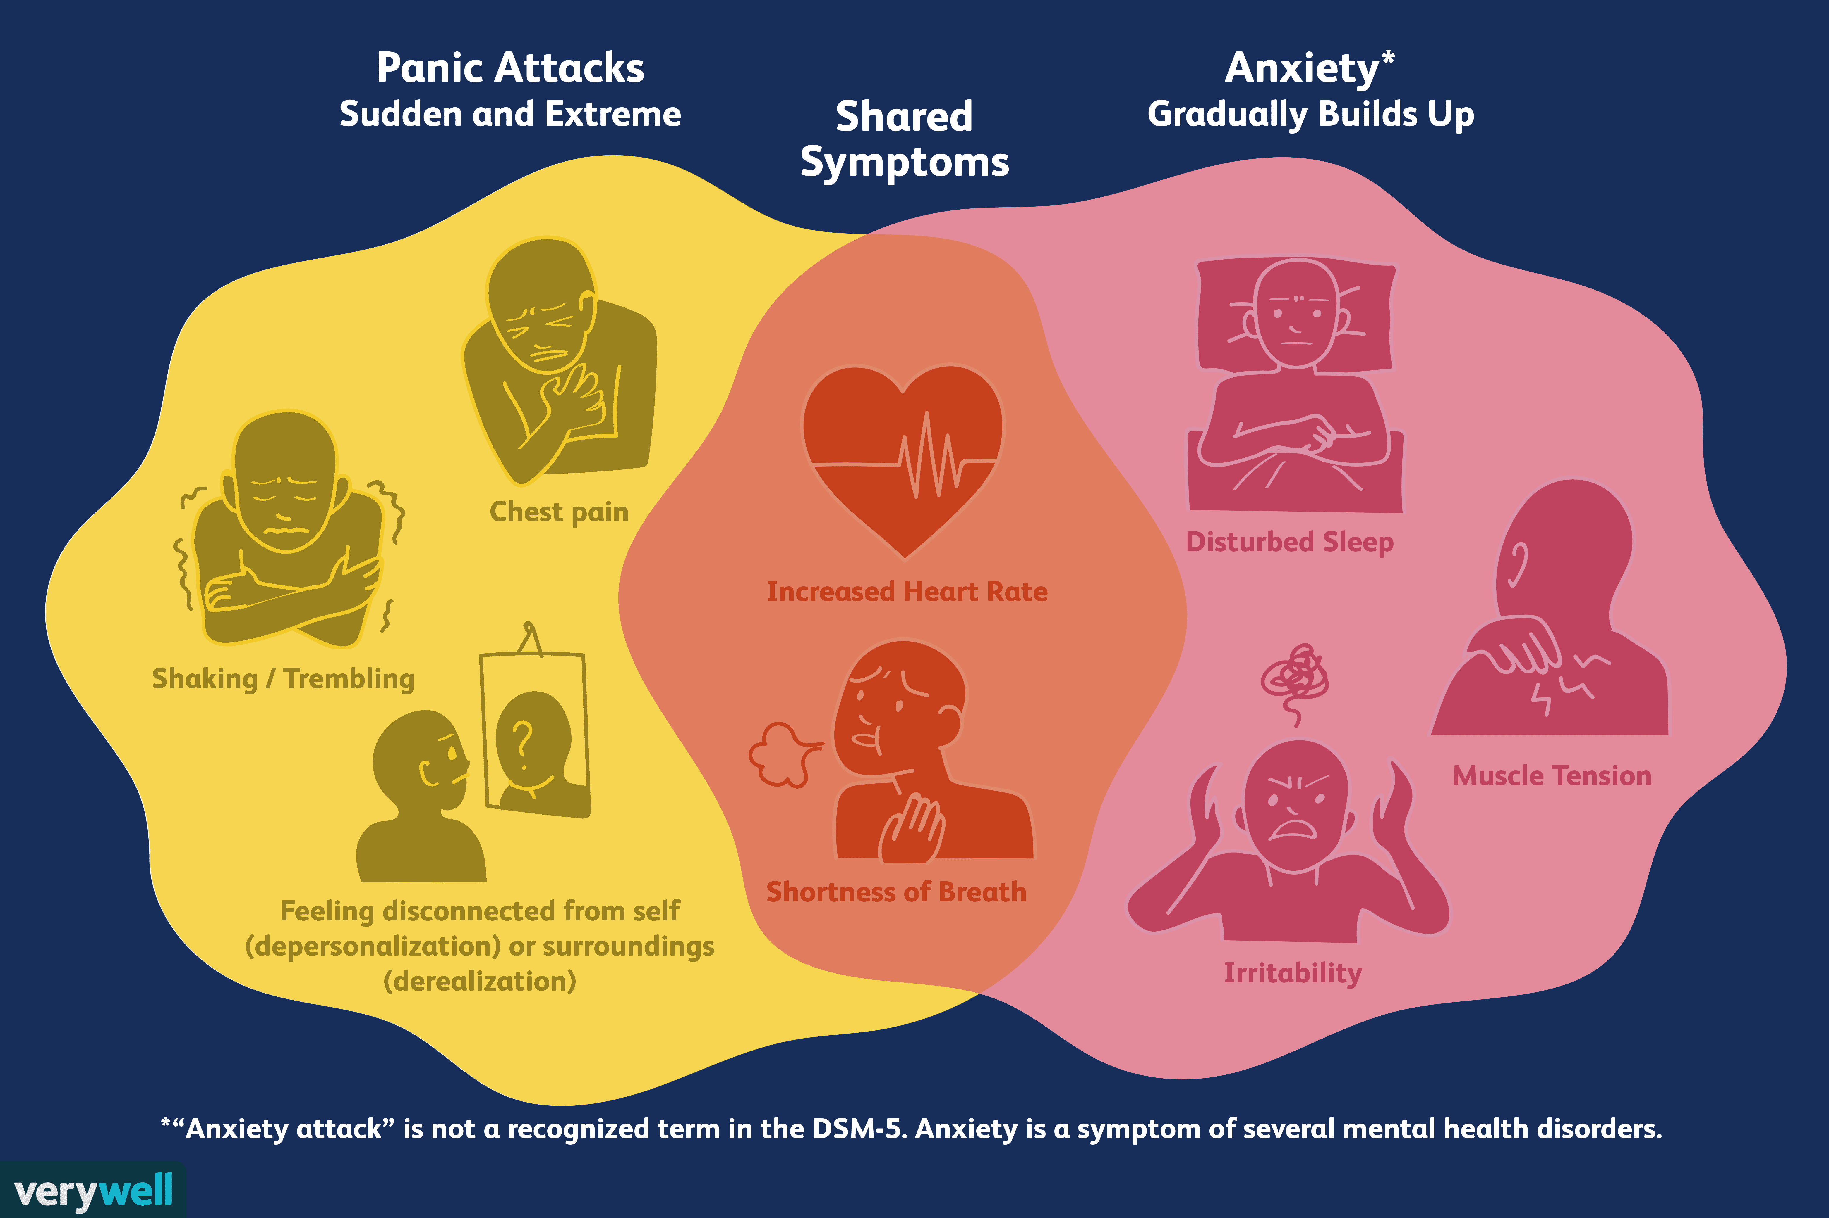

* Ensure you tell them that the feelings will pass, they just need to get their breathing under control to help and then distraction
* Grounding and deep breathing strategies

**Top tips?**



Some reasons why people may self-harm include; Expressing or coping with emotional distress, trying to feel in control, A way of punishing themselves, relieving unbearable tension, A cry for help or A response to intrusive thoughts.

**What are they?**

Suicidal feelings are when people have thoughts about ending their life or feel that people would be better off without them.

Self-harm is when somebody intentionally damages or injures their body.

**Top tips**

* Ensure you tell them that they need to speak to an adult in school or home and if they say no, then you will pass it on as you need to ensure that they are safe and get the support they need.
* If someone is in crisis you may need to get help from mental health services or the emergency services. **CAMHS crisis line number 01925 275309**
* Calm harm app – free to download on Apple and Android phone

**Self-harm and Suicidal thoughts**

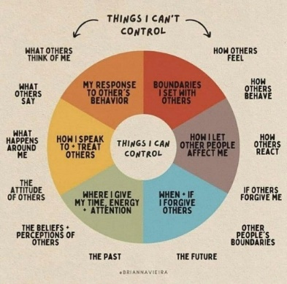

**What is it?**

Stress is a common feeling caused when things in life get too much or when we feel under pressure. Typical things can include pressures at school and home.

A small amount can be good and motivate us to meet our goals. But too much stress, when it feels out of control, can impact our mood, our well-being, and our relationships with people around us.

**Stress**

**Top tips**

* Encourage people to think about what they can and can’t control.
* Self-care is important as although it won’t solve all the problems which are making them stressed, it will put them in the best place to be able to handle the things that are causing them stress.
* Eat well and sleep: the better rested you are, the more able you are to cope with pressure.
* Awareness: once you are aware of difficulties that are likely to make you feel stressed you can take steps to prevent stress or deal with it quickly.

**Eating Disorders**



**What are they?**

* An eating disorder is when people will use food to try to manage their feelings, resulting in an unhealthy relationship with food.
* This may be eating too much or too little food, becoming obsessed with food and eating patterns.



**Top Tips**

* Ensure you tell them that they need to speak to an adult in school or home and if they say no, then you will pass it on as you need to ensure that they are safe and get the support they need.
* Try and get them to see the impact of not eating enough or too much including sleep, concentration, relationships, mood and achievement.





**Helpful numbers and apps** *(all free on Android and Apple devises)*

* **Kooth**—this is a free online counselling and emotional well-being platform for children and young people.
* **Woe bot**—A chatbot that helps people with low mood and anxiety
* **Calm Harm**— Calm Harm is an app designed to help people resist or manage the urge to self-​harm. It's private and password protected
* **Moodtrack Diary**—Monitor and track your emotional health. The app records a range of emotions for anxiety, depression, stress, post-traumatic stress and your general well-being.
* **Papyrus** – Call 0800 068 41 41 – 9am to midnight every day. Text 07860 039967
* **Childline** – Call 0800 1111 – the number will not show up on your phone bill
* **YoungMinds Crisis Messenger** - Text "YM" to 85258
* **CAMHS crisis line** - 01925 275309