St Gregory’s CEIAG Programme 2021-2022

CEIAG in the PSHCE Curriculum
To meet Gatsby Benchmark 4 during the academic year, each year group will receive CEIAG sessions during their PSHCE curriculum. Year 11 will receive sessions in the autumn term to correspond with their post 16 options. Year 7 to 10 will receive them during the start of the spring term. The CEIAG PSHCE lessons cover the six learning areas set out by the Career Development Institute (shown below). Further information about the CDI learning outcomes can be found here.

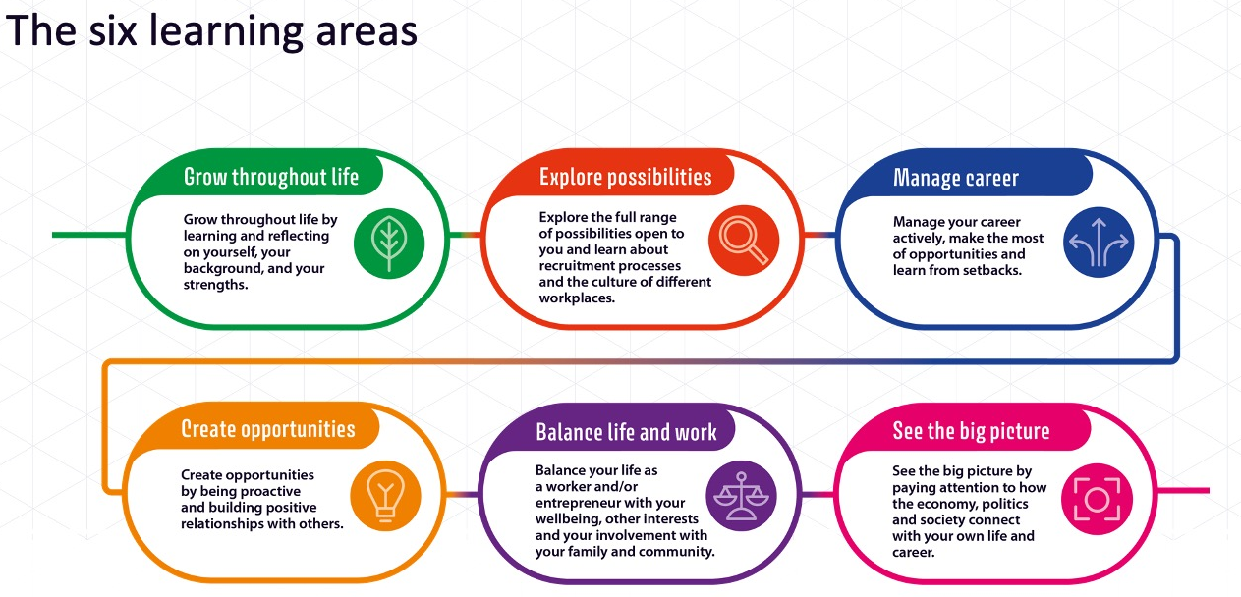
Year 7 Introduce:
In Year 7 pupils will be encouraged to identify their own strengths, interests and skills. They will consider what qualities employers would find desirable and reflect on themselves in order to set goals to enable their personal development.

PSHCE Session | Lesson Objective | Success Criteria | Career Development Skills.
- Stepping up from Primary School | To understand the changes you have experienced and the skills you have developed so far. | 1. I will reflect on my achievements so far.​  2. I will identify my personal qualities and give evidence for them.​  3. I will record and present information about myself in a positive way, including strengths, likes, interests and future hopes | 1 – Grow throughout life.  2 – Explore Possibilities.  3 – Manage your career.  4 – Create Opportunities.
- Skills for Life | To recognise the skills I already have and understand skills employers want. | 1. I will define hard and soft skills.​  2. I will identify my own skill strengths.​  3. I will create an action plan to improve areas of weakness. | 1 – Grow throughout life.  2 – Explore Possibilities.  3 – Manage your career.  4 – Create Opportunities.
- How to make good decisions | To evaluate how to make a good decision.​ | 1. I will evaluate what values are important to me.​  2: I will identify my strengths and areas for development when making decisions.​  3: I will consider the decisions I have to make during my time at St Gregory's. | 1 - Grow throughout life.  3 – Manage your career.  4 – Create Opportunities.  5 - Balance life and work.

Year 8 Inspire
In Year 8 pupils will be inspired by investigating people from a range of different backgrounds who have succeeded in their chosen career path. The concept of employability skills will be developed, and students will think about which skills they need to develop to be successful.
PSHCE Session | Lesson Objective | Success Criteria | Career Development Skills.
- Skills for Life | To recognise the skills I already have and understand skills employers want. | 1. I will define hard and soft skills.​  2. I will identify my own skill strengths.​  3. I will create an action plan to improve areas of weakness. | 1 – Grow throughout life.  2 – Explore Possibilities.  3 – Manage your career.  4 – Create Opportunities.
- How to be successful | To understand how to be successful in work & school. | 1. I will compare life in school with what I expect the world of work to be.​  2. I will identify roles that I think are successful.​  3. I will explain what motivates me. | 3 – Manage your career.  4 – Create Opportunities.  5 - Balance life and work.  6 – See the big picture.
- How to make the right decisions | To recognise the best ways to make decisions. | 1. I will describe what values are important to me.​  2. I will identify my strengths and areas for development when making decisions.​  3. I will explain how I can make insightful decisions about my next steps. | 1 - Grow throughout life.  2 – Explore Possibilities.  3 – Manage your career.  4 – Create Opportunities.  5 - Balance life and work.

Year 9 Enquire:
In Year 9 pupils will be encouraged to think about their own career pathway and will spend time using the internet to research different industries. In support of their Curriculum Pathways journey, in which students select the subjects they will go on and study at GCSE, every student is given access the Kudos website and its wealth of information. All pupils will be given the opportunity to receive a 20 minute 1:1 interview with our Careers Advisor to support them in making informed choices for their GCSEs.
PSHCE Session | Lesson Objective | Success Criteria | Career Development Skills.
- Exploring KS4 Opportunities | To understand the KS4 options available and what should influence my decisions. | 1. I will define KS4 and GCSE.​  2. I will create questions to make me critically think about my KS4 options.​  3. I will rank factors that will influence my KS4 option decisions. | 1 – Grow throughout life.  2 – Explore Possibilities.  6 – See the big picture.
- Exploring Career Opportunities | To understand different career possibilities and what can help me to make the right decisions.​ | I will identify steps to take to choose the right career path.​  2. I will explain what factors are important to me when deciding what career I want.​  3. I will create a 10-year plan. | 1 – Grow throughout life.  2 – Explore Possibilities.  3 – Manage your career.  4 – Create Opportunities.  5 - Balance life and work.  6 – See the big picture.
- Cronton & Riverside | Cronton & Riverside College options collective worship. |  | 2 – Explore Possibilities.  6 – See the big picture.

Year 10 Aim:
In Year 10 pupils will be expected to produce a Personal Statement, CV and a Career Plan for their St Gregory’s Diploma to help improve their confidence when applying for further education or employment. Pupils will continue to develop their knowledge of what skills and qualities employers find desirable and reflect on themselves in order to set goals to enable their personal development.
PSHCE Session | Lesson Objective | Success Criteria | Career Development Skills.
- The world of work | To understand the world of work and changes that are taking place. | 1. I will define what is meant by work.​  2. I will identify some key terms in the world of work.​  3. I will describe some of the key changes that have taken place in the world of work​ | 1 – Grow throughout life.  2 – Explore Possibilities.  6 – See the big picture.
- Managing money | To understand aspects of the economy and how it can influence how I budget my money. | 1. I will identify different areas of the economy and the links between them.​  2. I will describe how the economy might affect my decisions.​  3. I will explain the basic principles behind budgeting. | 1 - Grow throughout life.  3 – Manage your career.  5 - Balance life and work.
- How to write a CV and Cover Letter | To understand how to write a CV and covering letter. | 1. I will identify key employment laws.​  2. I will construct a cv based current education, skills and experience.​  3. I will create a cover letter for a job in the hospitality or retail sector. | 1 – Grow throughout life.  2 – Explore Possibilities.  3 – Manage your career.  4 – Create Opportunities.  5 - Balance life and work.

Year 11 Achieve:
In Year 11 pupils will look at the pathways available to them after their GCSEs. This will include information about apprenticeships and college courses. Local colleges will be invited to attend PSHCE sessions to ensure pupils are able to make informed decisions. Local job market information will be provided to help pupils identify where potential future employment opportunities may exist. All pupils will receive a 20 minute 1:1 interview with our Careers Advisor to support them in making informed choices for their post-16 options.

PSHCE Session | Lesson Objective | Career Development Skills.
Monday 27th September 10.05- 11.05 | Cronton & Riverside College collective worship | 1 – Grow throughout life.  2 – Explore Possibilities.  3 – Manage your career.  4 – Create Opportunities.  5 – Balance life and work.  6 – See the big picture.
Monday 11th October 11.25- 12.25 | Carmel College collective worship
Tuesday 2nd November 9.05-10.05 | Warrington and Royal Vale College collective worship
Tuesday 16th November 10.05-11.05 | A guide to open evenings
Tuesday 30th November 11.25-12.25 | Winstanley College collective worship
Tuesday 14th December 1.00-2.00 | Priestley College collective worship

CEIAG Extra-curricular Programme
Autumn Careers Club
Week A - Investigating careers of the 21st Century | Week B - Investigating your post 16 options
Wednesday 22 September: Green Energy.​  Wednesday 6 October: Artificial Intelligence Specialist.​  Wednesday 20 October: Cyber Security Specialist.​  Wednesday 10 November: Pharmaceutical Researcher.​  Wednesday 24 November: The Aviation Industry.​  Wednesday 8 December: App Developers. | Wednesday 15 September: An introduction to colleges in your local area.​  Wednesday 29 September: A guide to open evenings.​  Wednesday 13 October: A-levels or vocational courses- What is best for me?​  Wednesday 3 November: Is University the right option for me?​  Wednesday 17 November: Your Local Labour Market.​  Wednesday 1 December: Time to apply to your chosen college. ​  Wednesday 15 December: How to have a great interview.

Summer Careers Club
Tuesday 7th June: RAF guest speaker Antony.davenport276@mod.gov.uk
Tuesday 21st June: Police guest speaker Mike Fryer
Tuesday 5th July: Warrington Vale Apprenticeship Workshop

CEIAG Experience Events
Event | Date | Location |  | Year Involved |  |  |  |  | No. of pupils involved | Gatsby benchmarks
 |  | On site | Off Site | 7 | 8 | 9 | 10 | 11
Cronton College Prestigious University Event | 17/11/21 |  | Y |  |  |  | Y |  | 15 | 7
Chester University Introductory Conference | 15/2/22 |  | Y |  |  | Y |  |  | 30 | 3, 7
St Gregorys Careers Fair | 18/2/22 | Y |  |  |  | Y | Y | Y | 672 | 5
HS2 Epic Engineer Workshop | 28/6/22 | Y |  |  |  | Y |  |  | 60 | 3, 5
Cronton & Riverside College Taster | 8/7/22 |  | Y |  |  |  | Y |  | 238 | 7
Carmel College Taster | TBC |  | Y |  |  |  | Y |  | 50 | 3, 7
ASK Apprenticeship collective worship | TBC | Y |  |  |  |  | Y |  | 238 | 7

